# QES 2014-2018 financial reporting

The Quarterly Report template was modified in early April to allow for continuous reporting until the end of the project.

* A separate tab has been added for Advance requests per quarter (Y2Q4, Y3Q1, Y3Q2, etc.). Please make sure to enter data only in the ‘Advance Request’ tab of the period for which you are reporting. For the report due July 31st, you will need to enter data in tab ‘**Advance Request Y3Q1**’. REMEMBER to include all advances received to date.

* 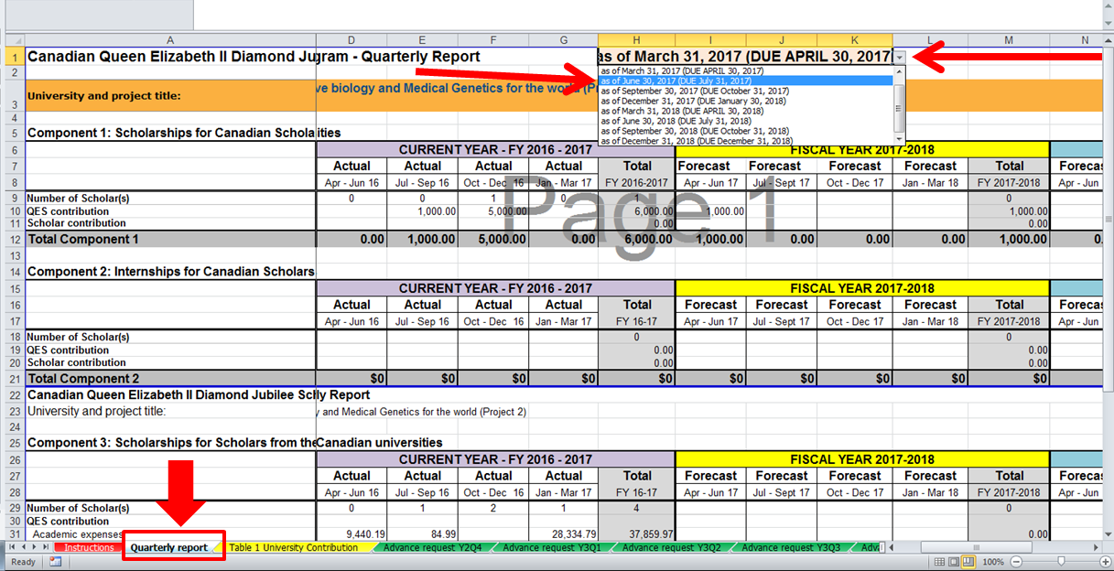You must use the approved version of your last report (Y2Q4) and simply change the reporting period by selecting the correct quarter in the drop down menu:
* Please make sure that your university and the name of your project are selected in Cell B3. If not, make sure to select them from the dropdown.

**IMPORTANT REMINDER:**

* Make sure that each scholar is reported only once, in the quarter in which the first QES disbursement occurred (or will occur).
* Make sure all ‘Actual Scholars’ have completed their Pre-departure form and it has been approved by the University
* Remember that effective May 1st, 2017, **scholars cannot access any QES funds until they have submitted their pre-departure form** (PDF) and it has been approved by the university.
* In ‘Table 1 University Contribution’, only indicate **actuals**. However, you must provide forecasts in the **Quarterly Report** tab.
* In ‘Table 1 University Contribution’, make sure actual amounts in Row 39 match the amounts in Row 42 (pulled from line 54 of the Quarterly Report tab). Row 42 will pull both actual and forecasted university contributions from the Quarterly Report Tab. You must not provide a breakdown in Table 1 for forecasted contributions.