Quarterly Report
Instructions

Quarterly report tab
IMPORTANT: Quarterly reports must be presented on the EXCEL template provided. Once the initial quarterly report has been approved, each subsequent report must be submitted using the same document.

- Cell B1: Select the reporting period from the drop-down menu. The first one is referred to as the Initial financial workplan
- Cell B3: Select your university from the drop-down menu.

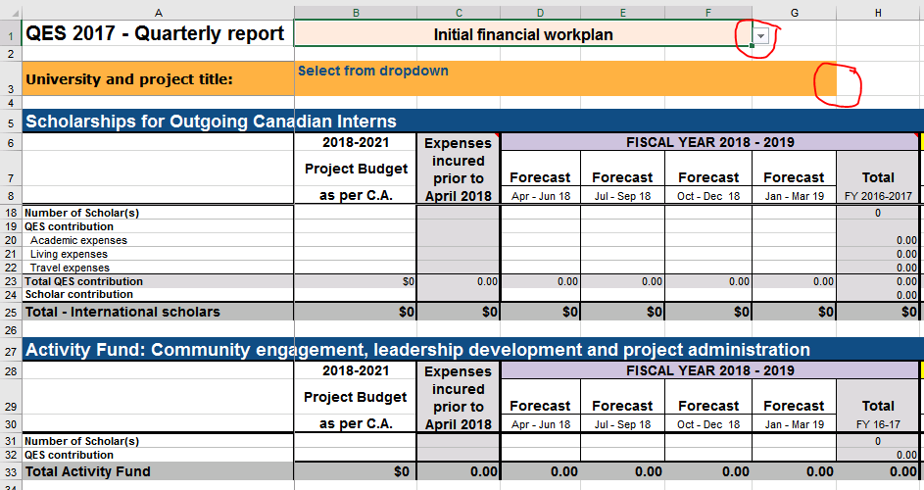

- Column B: Enter the amounts that were agreed upon in the signed contribution agreement. This column must never change unless there is a fully executed amendment.
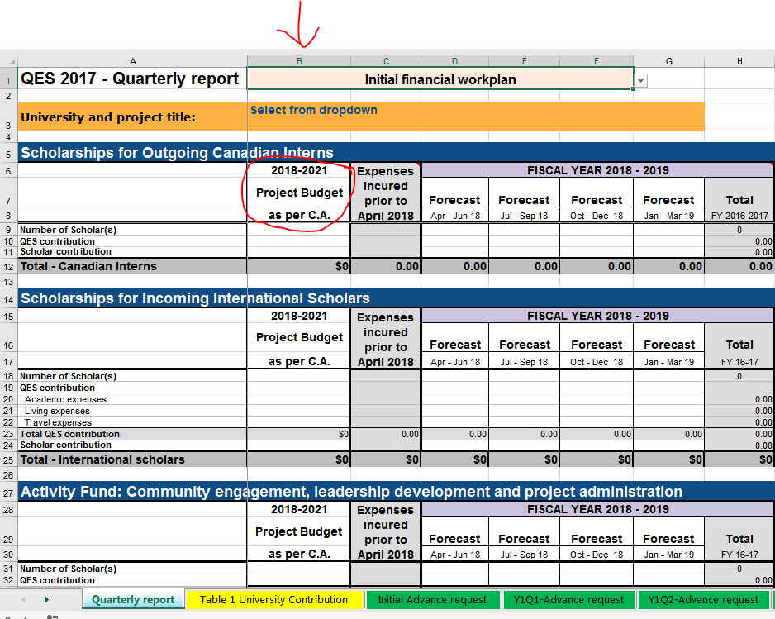

- Column C: Enter any actual expenses that were incurred before April 2018. This only applies to Universities that had a fully executed contribution agreement dated before April 1, 2018.

- Column D: Enter any eligible expenses that are forecasted for the period April 1 – June 30, 2018.
- Columns E, F, G: Enter forecasted expenses in each of the quarters for the rest of the fiscal year 2018-2019.
- Column H: This column automatically calculates the total for the fiscal year based on the expenses inserted in columns D – G.
- Column I, J, K, L: Enter the forecasted expenses for the period of April-June 2019, July-September 2019, October-December 2019 and January-March 2020 periods.
- Column M: This column will calculate automatically
- Column N, O, P, Q: Enter the forecasted expenses for the period of April-June 2020, July-September 2020, October-December 2020 and January-March 2021 periods.
- Column R: This column will calculate automatically
- Column S, T, U: Enter the forecasted expenses for the period of April-June 2021, July-September 2021, and October-December 2021.
- Column V: This column will calculate automatically.

IMPORTANT:
- Ensure totals for outgoing Canadians don’t exceed $6K (or $8K if scholar’s internship is longer than 180 days).
- Ensure scholars are reported only once in the report (1 x in row 9 OR row 18 and 1 x in the Activity Fund section (row 31)). Although there may be expenses associated to a scholar in more than one quarter (for international scholars in particular), he or she must be counted in the quarter where the first expense was incurred.
EXAMPLE:
A Canadian intern scheduled to travel in May 2018 would be reported in the April-June 2018 quarter AS WELL AS in row 31:
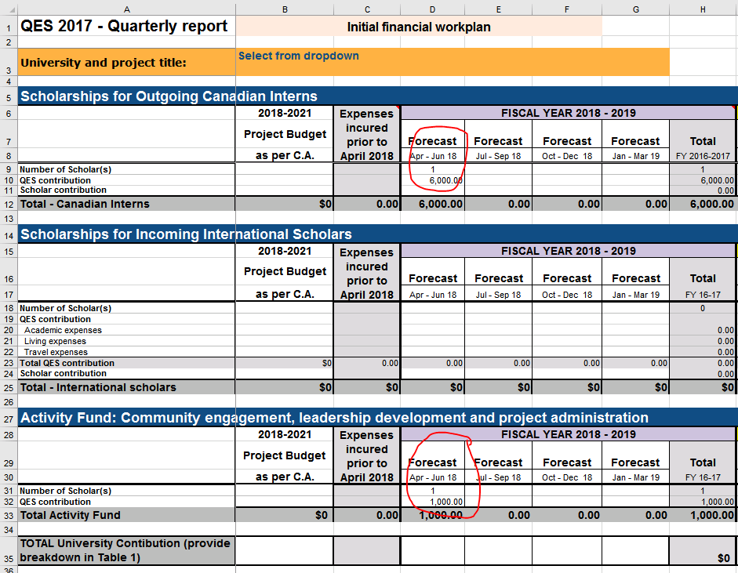

- Ensure QES contribution to the Activity Fund is not more than $1000/scholar/year or less, as per the approved budget. This amount must be requested in the same quarter in which the scholar is reported. In the case of incoming international scholars in Canada for more than 12 months, an additional $1000 can be claimed in the same quarter as the first $1000, the following year (i.e. Aug 2018 = Aug 2019), assuming it was included in the budget.
- Ensure the total number of scholars in cell W31 is equal to the number in cell W41.
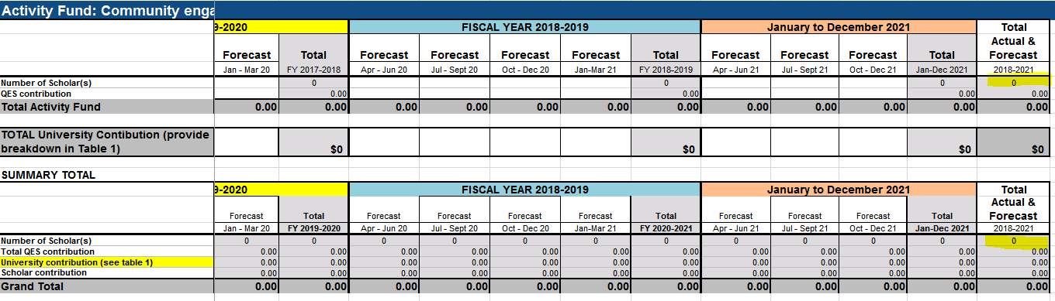
- Ensure that the Forecast totals (cells W42, W43 and W44) are in line with your approved Budget totals (cells B42, B43 and B44) as stated in your Contribution Agreement (CA). Universities Canada understands that over the life of the project your forecasts may fluctuate but please note that the TOTAL QES Contribution amount in cell B42, as indicated in your CA, cannot be exceeded. The University and Scholar contributions (cells B43 and B44) may change over time but please keep in mind that any reduction to the University/Scholar contribution could result in a reduction of the QES contribution.
- Any changes from inbound scholarships to outbound scholarships must be discussed with the QES program manager. Should changes in your project activities require an amendment to the CA, please contact Universities Canada for discussion and approval before including such changes in your quarterly report.

Table 1 – University Contribution tab
- Following the definition below of university contribution, please break down these expenses by cash or in-kind contributions in Table 1 University Contribution.
- This tab must include only actual expenses. The forecasted university contributions must be included in row 35 of the Quarterly Report tab, NOT on Table 1. Please do not insert any forecasts in this table.
- Ensure the amounts in Row 39 ‘Grand Total’ are the same as the amounts in Row 42 ‘Amount Reported in Quarterly Report’.
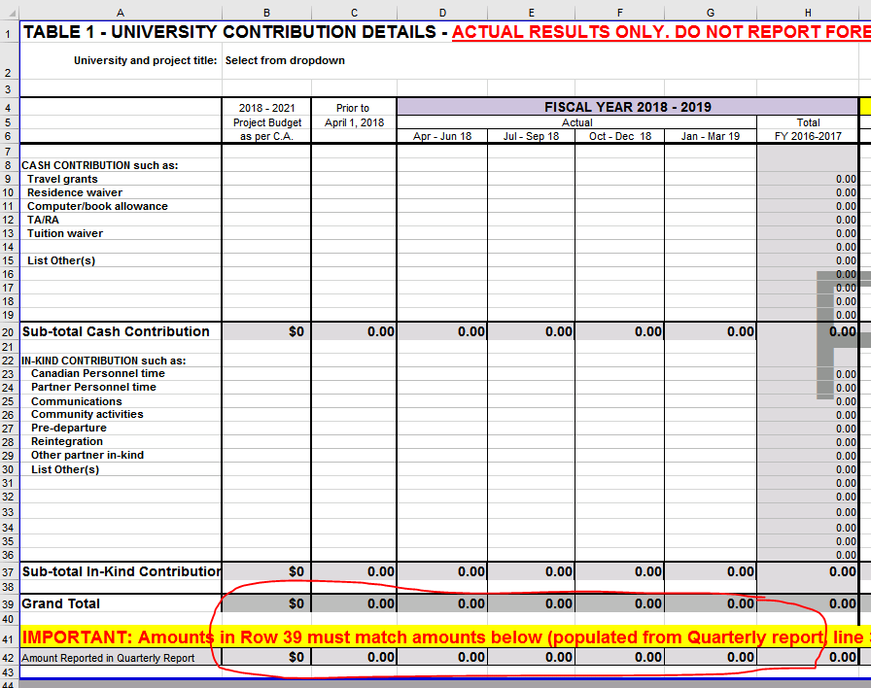

Advance request tabs
- Make sure to select the advance request tab corresponding to the correct reporting period.
- Insert the cumulative total advance payments received from Universities Canada in cell G8. Add the sum of all the cheques received to date, even if they were not all cashed during the reporting period.
- Insert any cumulative interest earned in cell G10.

Definitions
Term | Definition
Academic expenses | The costs directly related to tuition, supplies, research and conferences during the scholarship or internship.
Living expenses | The costs directly related to food, accommodation, health insurance and installation during the scholarship or internship.
Travel expenses | The return airfare, in-transit allowances, visa or study permit costs for the scholarship or internship.
QES contribution | The funds from the Canadian Queen Elizabeth II Diamond Jubilee Scholarships program.
University contribution | The cash, in-kind and leveraged contribution provided by the university. This can include:  • In-kind or cash contributions (as per the Department of Foreign Affairs, Trade and Development's definition in the Contribution Agreements - Terms and Conditions);  • Tuition waivers or discounts;  • Other discounts or waivers to academic, living or travel costs;  • Financial contributions from other sources including foundations, community partners and other funding agencies.
Scholar contribution | The cash the student contributes towards academic, living or travel costs during the scholarship or internship.

